**Legend**

**Wind Instruments**

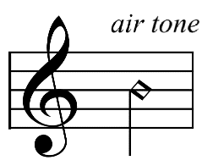

= with 50% air and 50% tone

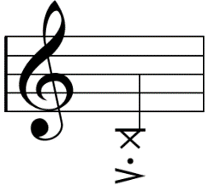

= pitched key clicks

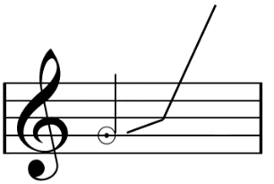

= jet whistle

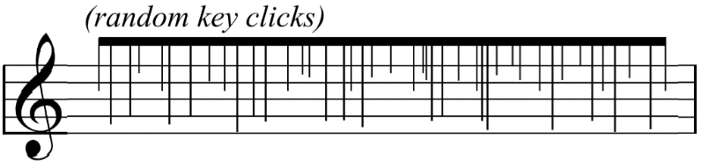

= random key clicks

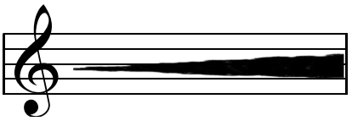

= 100% breath tone and 0% tone

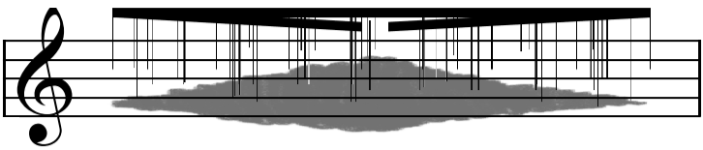

= random key clicks with breath tone

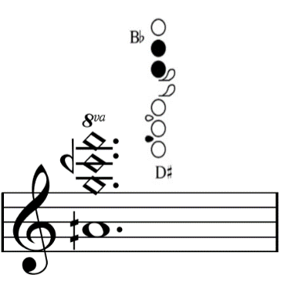

= multiphonic

**String Instruments**

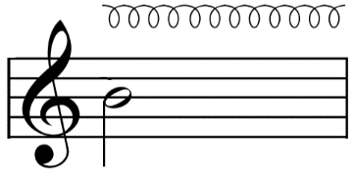

= circular bowing

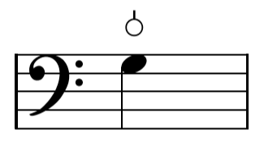

= Bartok pizzicato

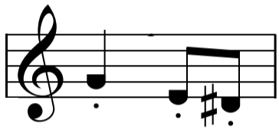

= with half pressure on string

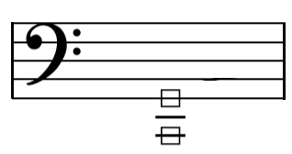

= scratch tone

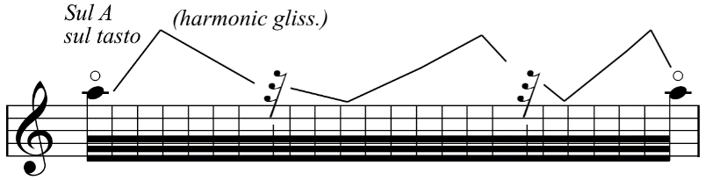

= harmonic glissando, lines indicate the position on string rather than pitches

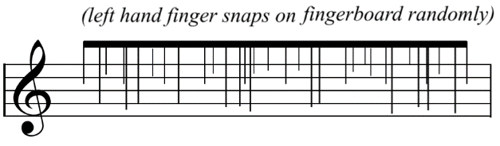

= left hand fingertips snap; random strings and positions on string

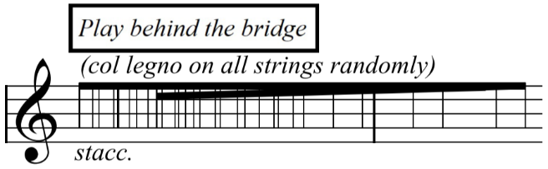

= with col legno battuto, use all strings moving randomly between them

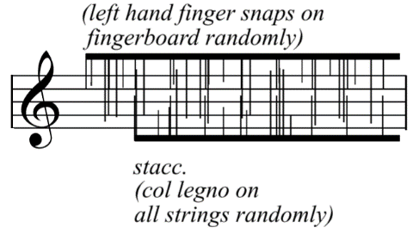

= “left hand snaps on fingerboard” plays along with “col legno on all strings”

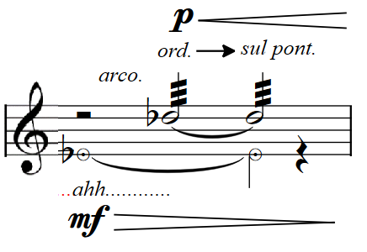

= sing and play together

**Other Signs**

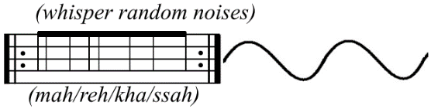

= whispering with random syllables

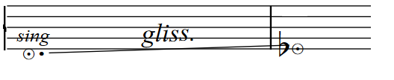

= sing